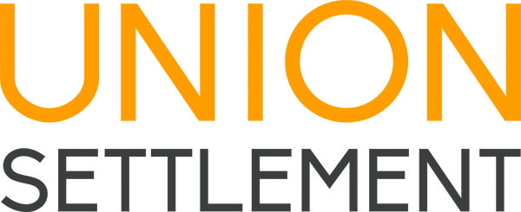

EMPLOYMENT OPPORTUNITY

Union Settlement Association is an on-the-ground resource for East Harlem residents of all ages, and a passionate advocate for the needs of underserved communities. Since opening our doors in 1895, we have brought education, wellness and community-building programs to our neighborhood, empowering New Yorkers with opportunities to better their lives. More than 350 staff work in our organization, and our services impact 10,000 people every year. By helping our neighbors realize their goals, we build the vitality and success of East Harlem. For more information about Union Settlement, please visit our website at www.unionsettlement.org.

Position: NORC Case Manager
Department: Senior Services
Reports to: NORC Director
Hours: Full-Time

Position Summary:
The NORC Case Manager is responsible for providing comprehensive case management and case assistance to residents age 60+ of the Franklin Plaza Apartments.

Responsibilities:
- Provide case management services to NORC participants via home and office visits. Conduct comprehensive needs assessments and develop and implement care plans based on identified needs. Conduct regular follow-up to ensure that participants’ needs are being met. Meet with family members, caregivers, and others who play a key role in the participants’ lives as dictated by the care plan. Provide short-term case assistance as indicated.
- Meet contractual obligations related to service units of case management and case assistance.
- Identify appropriate resources to respond to participant needs and make any referrals necessary to implement care plans. Provide follow-up with clients and collateral contacts as indicated.
- Conduct annual registrations of participants.
- Input data into the Department For The Aging database and maintain comprehensive electronic and paper case files, including intakes, care plans, case progress notes, event participation, and units of service provided, as well as any important documents.
- Provide appropriate group interventions and workshops related to frequently identified needs of the client population such as diabetes, weight management, depression, etc.
- Develop, implement and administer a wide variety of ongoing new and cutting-edge health and wellness programs, as well as cultural programs to benefit NORC participants. Make referrals for wellness activities and socialization as appropriate.
- Plan and assist at special events for NORC participants, such as parties, concerts, and trips.
- Administer and support volunteer involvement in the NORC.
- Collaborate with the NORC Outreach Team and NORC Neighborhood Network to identify residents as potential program participants.
- Perform outreach to potential participants via telephone contact, door-to-door canvassing, and other means. Inform Franklin Plaza residents about NORC activities, seek participation in the Health Indicators and other surveys, and connect residents with NORC services and activities. Collect data about residents and report results to the NORC Director for follow up.
- Supervise interns as assigned by the NORC Director.
- Liaise with partners and community groups.
- Conduct occasional community outreach and marketing, raising awareness of the NORC program to potential new community partners who might provide services to residents in other ways (referral sites, volunteer, cultural or employment opportunities, etc.).
- Assist the NORC Director with reporting and with administrative projects as indicated.
- Additional duties as assigned by the NORC Director.

Qualifications:
- Bachelor’s Degree in Social Work or related field.
- Demonstrated case work experience preferred.
- Demonstrated experience with aging populations preferred.
- Understanding of the aging process and its impact on individuals physically, socially, mentally and psychologically.
- Demonstrated experience with working as a member of an interdisciplinary team.
- Experience with volunteer management a plus.
- Excellent organizational, verbal, written, and interpersonal skills.
- Strong problem solving skills.
- Excellent computer skills.
- Demonstrated ability to perform multiple tasks effectively in a fast-paced, challenging, and constantly changing environment.
- Knowledge of East Harlem community and health/service networks and resources in East Harlem a plus.
- Previous experience within a NORC a plus.
- Bilingual (English/Spanish or English/Chinese) preferred.

To Apply:
Please send cover letter, resume, salary requirements, and contact information for at least three professional references to:
Jobs@unionsettlement.org
Please indicate NORC Case Manager in subject of e-mail.

UNION SETTLEMENT ASSOCIATION IS AN EQUAL OPPORTUNITY EMPLOYER

