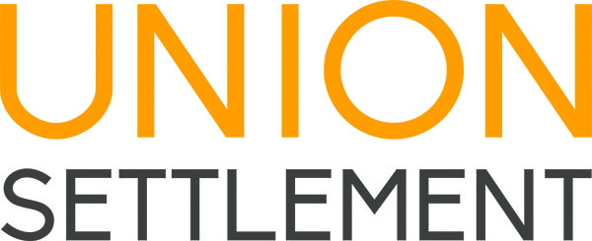

EMPLOYMENT OPPORTUNITY

Union Settlement Association is an on-the-ground resource for East Harlem residents of all ages, and a passionate advocate for the needs of underserved communities. Since opening our doors in 1895, we have brought education, wellness and community-building programs to our neighborhood, empowering New Yorkers with opportunities to better their lives. More than 350 staff work in our organization, and our services impact 10,000 people every year. By helping our neighbors realize their goals, we build the vitality and success of East Harlem. For more information about Union Settlement, please visit our website at www.unionsettlement.org.

Position: M007 Program Director
Department: Youth Services
Reports to: Assistant Director of Youth Services
Hours: Full-Time

Position Summary: The Program Director at Samuel Stern Middle School (M007) is responsible for the day-to-day operation of the program. Responsibilities include, but are not limited to the hiring, training, evaluation, supervision, and management of daily operations of a diverse staff ranging from seasoned activity specialists to high school interns. Additionally, the Program Director is responsible for program development, managing relations with schools and program partners, managing the program’s budget, and meeting all contractual DYCD obligations. The Program Director will be responsible for marketing the program to target communities and schools, representing the program at off-site meetings and conferences, and establishing relationships with Community Based Organizations (CBO’s). The individual will participate in grant writing and fundraising efforts on behalf of the program, as needed.

Responsibilities:
- Implement a program with a focus on social and emotional support activities, and tied to project based learning.
- Ensure SONYC database is updated weekly including attendance, work scope, program schedule, and staffing.
- Ensure Challenge Based Learning, Clubs, and Health and Wellness workshops, which allow the students to learn in smaller groups.
- Develop preventative activities and workshops to address, at minimum, the following issues: gang involvement, teenage pregnancy, obesity, risky sexual behavior, and substance abuse.
- Create and maintain a welcoming, productive, and encouraging environment for participants, their families, and members of the community.
- Ensure a strong relationship between the school day curriculum and the SONYC program; conduct regular meetings with the principal and/or key school staff, and attend school and curriculum development trainings.
- Assist in the development, implementation, and management the Middle School STEM Summer Academy.
- Articulate the program’s vision, mission, and goals to East Harlem CBOs, school staff, administrators, students, families, and community leaders to generate support.
- Facilitate monthly team meetings with program staff and partners.
- Provide weekly supervisory meetings with all staff and component consultants’ staff to discuss performance, strengths and challenges.
- Produce program reports as needed.
- Additional duties as assigned by the Assistant Director and Director of Youth Services.

Qualifications:
- Master’s Degree in Social Work or related field strongly preferred; at minimum, Bachelor’s Degree in Social Work or related field.
- At minimum, three years experience in youth development programs providing educational enrichment activities, with demonstrated success providing services to middle school-age youth in a direct service or supervisory role.
- Knowledge of performance-based contracts.
- Familiarity with the DYCD funded OST programs.
- Demonstrated experienced in practicing youth development principles and working with urban youth ages 11 to 15.
- Demonstrated understanding of the challenges facing youth in an urban setting.
- Ability and commitment to create a positive environment built on supportive relationships among staff and students.
- Capacity to empower staff to serve as role models for students and create high expectations for student behavior, school and program attendance, work habits, and attitudes toward learning
- Strong verbal and written skills.
- Strong, demonstrated computer skills.
- Demonstrated ability to perform multiple tasks effectively in a fast paced, challenging, and constantly changing environment.
- Strong commitment to working with youth.
- Bilingual (English/Spanish) preferred.

To Apply:
Please send Cover Letter, Resume, Salary Requirements, and 3 Professional References to:
hr@unionsettlement.org
Please indicate M007 Program Director in the subject of e-mail.

UNION SETTLEMENT ASSOCIATION IS AN EQUAL OPPORTUNITY EMPLOYER

