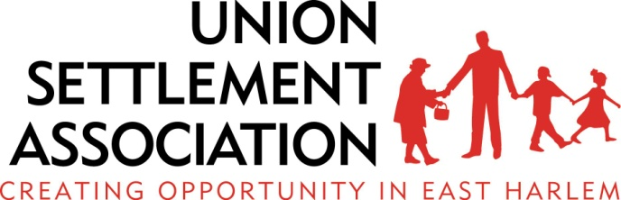

Job Description

Position: Development Assistant
Department: Development
Reports to: Director of Development and Communication
Hours: Full-Time
FLSA: Exempt
Reviewed: 9/23/12

Position Summary:
The Development Assistant plays a key role in two areas: donor relations and grant writing, and will be responsible for a variety of tasks related to corporate, foundation and individual giving, including managing relationships with current and prospective donors, and researching ways to bring in additional funds and maintaining the donor database. The Development Assistant also assists with writing annual reports, proposals, grant reports, newsletters and researching foundations and other potential funding opportunities. The Development Associate works closely with the development team, as well as program staff, to raise the private funding necessary to maintain essential community services and invest in new programming.

Responsibilities:
- Provide overall support for fundraising initiatives including the annual appeal and special events, ranging from donor acknowledgment letters, receipts and other donor correspondence.
- Manage donor database, including generating and modifying development reports; provide tracking, filing and data entry to ensure accuracy in follow-up and reporting of fundraising outcomes.
- Compile and distribute regular weekly/monthly reports.
- Coordinate mailings for donor communications, donor acknowledgement letters, receipts, event invitations and follow up, and any other donor correspondence, working with other Development staff to ensure quality, accuracy, and timely execution. Includes finalizing, packaging and mailing annual appeals.
- Write reports, proposals and acknowledgments for a range of audiences including foundations, corporations, religious organizations, government agencies, and individual donors.
- Work with agency program staff to secure and maintain grants for general support and support of programs.
- Conduct research to find funding opportunities and potential donors.
- Provide administrative and logistical support in planning and executing donor cultivation events and programs designed to cultivate and steward relationships with donors and maximize giving potential.
- Assist with fundraising events.
- Special projects and duties as assigned by supervisor.

Qualifications:
- Bachelor’s Degree in related field and two years of demonstrated experience in a related position; Master’s Degree in related field a plus.
- Strong writing and editing skills. Previous development and/or grant writing experience preferred and the ability to persuasively convey program results through donor communications.
- Excellent computer skills; Microsoft Word and Excel experience essential.
- Experience with donor databases preferred.
- Excellent organizational ability and interpersonal skills.
- A dedicated work ethic, diligence, and readiness to be a hands-on team member with a keen eye for detail.
- Overall flexibility and ability to work under pressure and meet many deadlines.
- Familiarity with social service programs.
- A strong desire to help improve the lives of the residents of the East Harlem community.
- A sense of humor.

_____________________ ________________________ ___________
Employee Name Employee Signature Date

