Volunteer with Union Settlement
Group and Individual Volunteer Opportunities
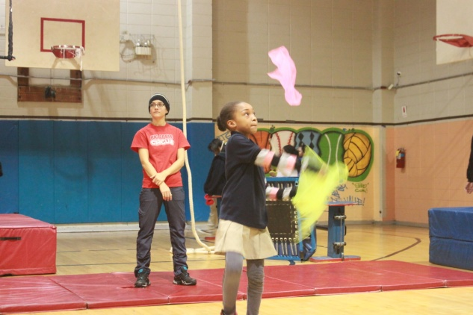
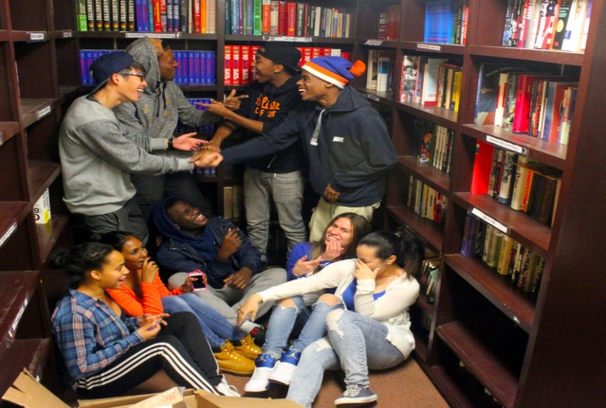
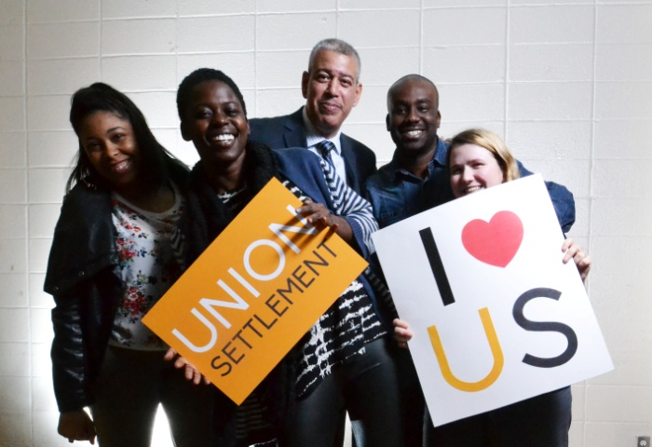
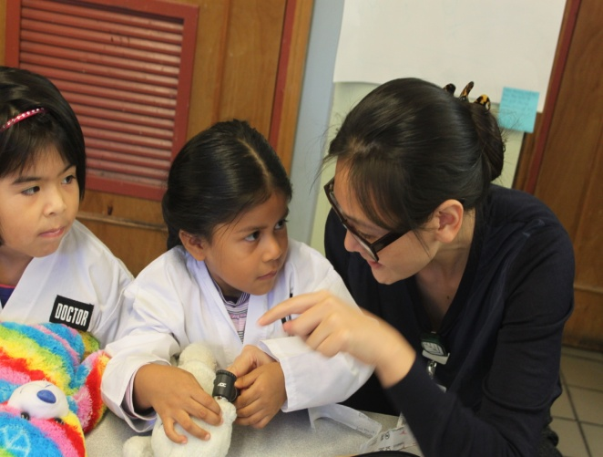
2016 - 2017
Volunteer as a Group
Interested Volunteers Should Contact

Cristina Valbuena-Castor
Development Associate - Donor & Volunteer Relations
646-672-5082
cvalbuenacastor@unionsettlement.org

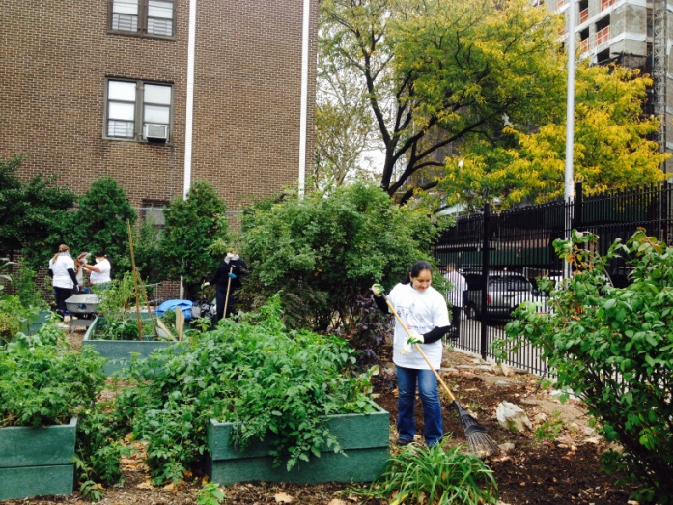
Gardening – *NOTE* Our community garden, El Sitio Feliz, will be closed for renovations from June through August 2016.
Fall and Winter are important times for the garden to regenerate, and we have a lot to do to prepare for the colder months! Lend a hand with cleaning and weeding in our large community garden, El Sitio Feliz, located at 237 E 104th Street or with a group of seniors at one of the smaller Senior Center Gardens at various locations in East Harlem. During the spring, volunteer groups can join us for a “planting party” to help revitalize our gardening beds at the end of April of beginning of May! Gardening can take place any day, morning or afternoon. Any size group between 5-40 volunteers is welcome.
Does your group have green thumbs? We are looking for an energetic group to adopt El Sitio Feliz! Whenever you want to garden, you will be able to do so.
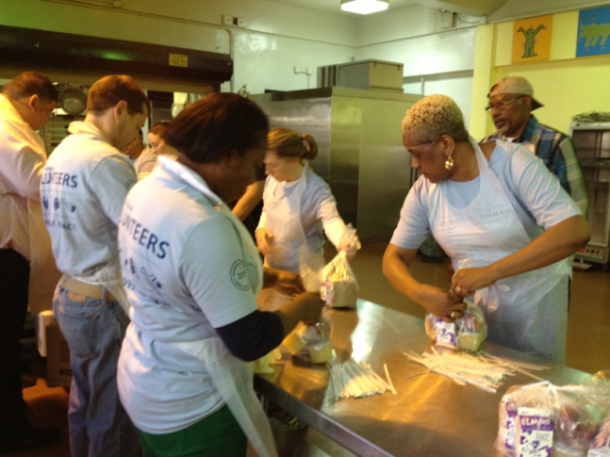
Meals on Wheels – Help pack and deliver meals to hundreds of seniors in the East Harlem community. Volunteers pack the food then separate into teams to deliver meals to seniors either on foot or in our transport vans. Many of our seniors are homebound and live alone, so volunteers provide them with a warm meal and give them someone to talk to. Meals are delivered Monday-Saturday, 9:00am-12:30pm. Weather emergencies provide a special challenge and are a great opportunity to help. Groups of 12 are preferable. On Thanksgiving (November 24) and Christmas (December 25), groups of 25 are preferable.
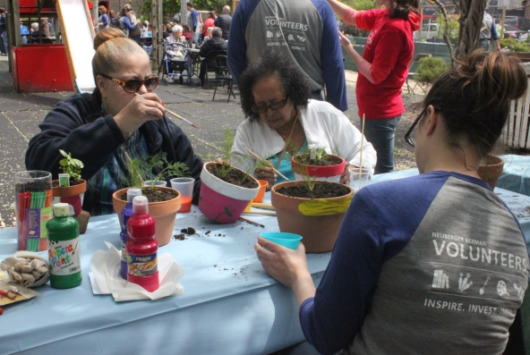
Garden-Themed Party – Volunteers can host a party in our community garden that focuses on the theme of environmental education. This event can include 10-25 preschool children ages 2-5 or older students ages 6-12 in our afterschool programs. Volunteers would assist students in participating in activities like planting a seed to take home, a cooking demonstration or taste test, or an environmental art project, such as painting garden signs from reused materials. This event would take place between 3:30pm-6pm on a weekday. Groups between 5-40 volunteers are welcome. You can also help with a Senior Garden Party from noon to 3pm on weekday - arrive early to help with decorating and set-up, help serve food, dance and party with the seniors and stay to help staff clean up. Groups between 3-7 volunteers are welcome.
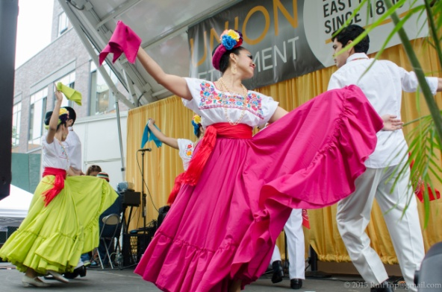
Ethnic Festival – Sponsor our annual international block party that celebrates the cultural heritage and diversity of East Harlem! Volunteers can assist with a variety of tasks ranging from set-up and decorating the block to arts and crafts for both kids and adults. This is our biggest public event of the year that includes music, dance, ethnic cuisine, and educational activities for the whole family. This takes place in May and groups between 15-40 volunteers are preferable.
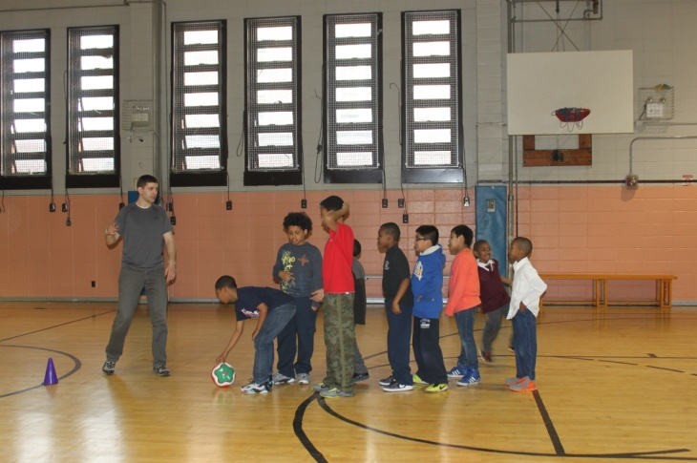
Summer Camp Olympics – Work with us to create a “mini-Olympics” for our 200 Summer Day Camp participants, ages 6-12. Volunteers will organize the children into groups and lead them through a variety of activities inside our gym and community room. Scheduling is flexible over the summer months. Any size group between 15 to 40 volunteers are welcome.
Young Father’s Day BBQ – Each year we work with 85 non-custodial fathers to offer parenting workshops, job counseling, and professional development. Join these fathers and their children for an early Father’s Day BBQ in June. Volunteers are needed to set up and staff the party, as well as to spend some time with the fathers and kids. Great volunteer opportunity for fathers!
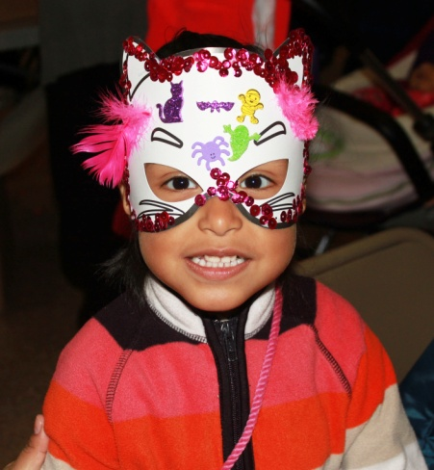
Fall Crafts – Celebrate fall with our afterschool program by hosting a number of activities around the theme of fall in our community garden. Students can create crafts with leaves, color fall themed designs, build a scarecrow for the garden, and any number of other fall themed activities. These events will take place after school from 3:30-6:30 any day of the week. Groups between 15-25 volunteers are preferable.
Holidays
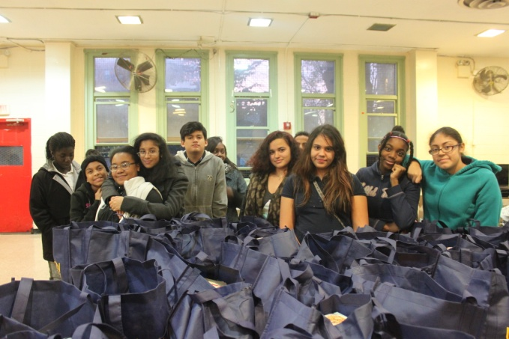
Meal Service – Help serve holiday meals for seniors and add holiday cheer at our Senior Centers. Serve meals at either Gaylord White Senior Center at 2029 Second Avenue, or Corsi Senior Center at 207 East 116th Street. Large Groups are preferable.
Thanksgiving Food Drive – Spend a morning filling bags with food, or an afternoon giving out those bags, during our yearly Thanksgiving Food Drive. We distribute approximately 275 bags filled with turkey and trimmings to families in East Harlem. This happens in the days before Thanksgiving.
Holiday Gift Drive – Hold a gift drive at your office, place of worship, or just among friends. Every year we collect hundreds of gifts for children ages 2-13 and senior citizens. We rely entirely on support from volunteers and corporations to make the yearly gift drive possible. Boxes should be displayed in early December. Gifts will be picked up by December 16 (tentative).
Gift Wrapping Party – Help us wrap the thousands of gifts we get donated. We ask volunteers to come to Union Settlement at 237 East 104th Street in groups for social “wrapping parties.” Wrapping parties are scheduled during mid-December
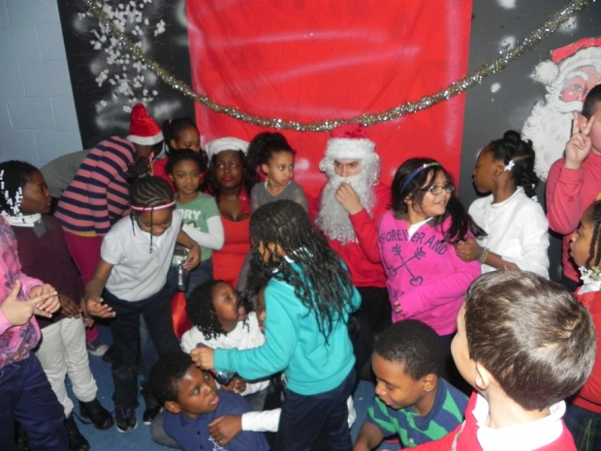
Host a Holiday Party – Each of our preschools, senior centers, and after school programs holds its own holiday celebration (totaling anywhere from 9-14 holiday parties a year), so we need a lot of extra hands! Help decorate a center and enjoy festive activities with guests. Parties usually occur right before the holidays. Any size group is welcome, although we prefer groups of 5-20 volunteers.

Volunteer as an Individual
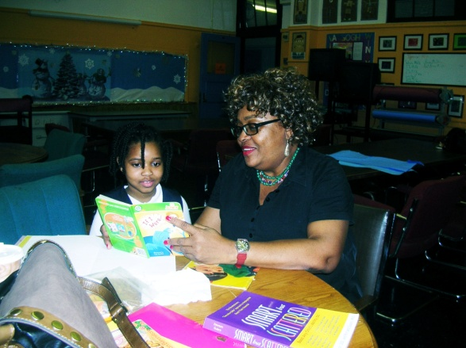
Homework Helper at Rising Stars – Assist children ages 5-12 with their homework in our afterschool program located at our Washington Community Center, 1775 Third Avenue (at 98th Street). The program run Monday - Friday from 3:00pm-5:00pm. Volunteers are given curriculum and help with general subjects such as Math and Reading.
Elementary School Homework Helper – Assist special needs children in elementary school with their homework in our afterschool program located at PS 138 (East 128th Street between 3rd Avenue and Lexington Avenue). The program runs Monday – Friday from 3:00pm-4:00pm. Volunteers who have experience working with children with special needs especially welcomed.
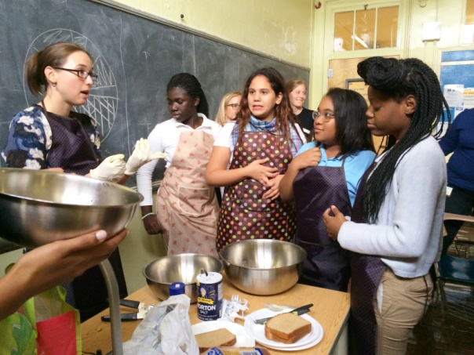
High School Equivalency Teaching Assistant – Volunteers will prepare Adult Education students in East Harlem to take the High School Equivalency (formerly GED) exam by teaching basic math, writing, reading comprehension, grammar, and social studies. Volunteers will work alongside a full-time staff teacher teaching a class of 15-20 students. Curriculum and materials will be provided 5 days in advance of the class. Classes take place at 237 E 104th St, New York, NY. Reading, writing, and social studies classes are held Mondays and Wednesdays from 12:00pm-3:00pm. Math classes are held Mondays-Thursdays from 12:00pm-3:00pm. Volunteers are encouraged to commit to individual trimesters, with the entire school year running from September 15, 2014 to June 18, 2015.
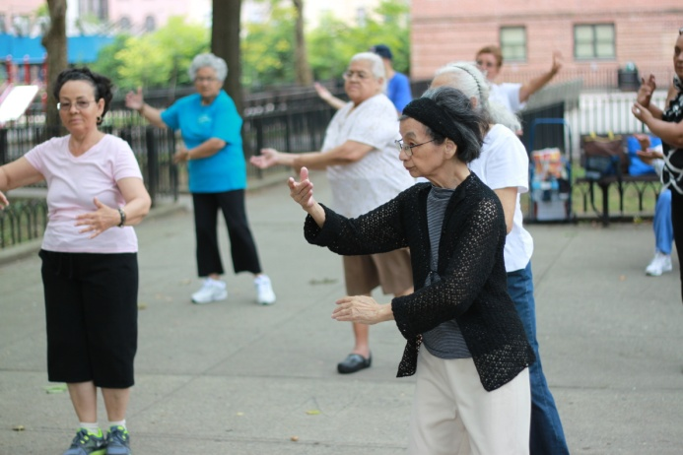
Literacy Partners – Improve the overall English fluency of Union Settlement Adult Education students, with a particular focus on literacy. Strong English skills are required, and being bi-lingual is a plus. Volunteers will work one-on-one or with a small group to cover provided curriculum. Classes take place Monday through Thursday in the mornings and evenings at 237 E 104th St, New York, NY. Volunteers serve at least one shift per week based on volunteer availability.
Senior Activity Specialist – Help develop and implement exercise or recreational activities, such as dance, knitting, and art, for senior participants in Union Settlement’s programs. Volunteers will assist in the creation of educational materials for senior activities and motivate seniors. The activities are held weekday mornings and the commitment is at the discretion of the volunteer.
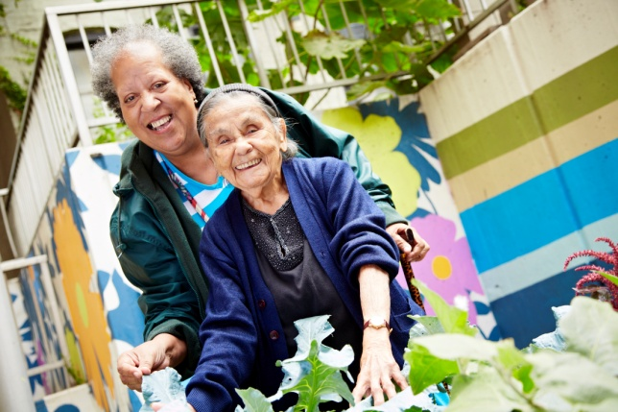
Friendly Visiting – Visit Seniors in their homes for an hour each week. During that time volunteers can chat, read aloud, go for a walk, play board games, and assist with light errands. Volunteers should commit to 3-4 hours per month for 3-6 months.

Senior Phone-Chats – Volunteers can call a Senior to check on them and have a friendly conversation. Volunteers should commit to 2-4 hours per month for 3-6 months.

Beautification & Maintenance Volunteer – Help improve the appearance of our centers by gardening, painting or cleaning.

Administrative Assistant – Volunteers will help with filing and data entry in any of our locations. Commitment is between 2-5 hours per week.

